Supporting the
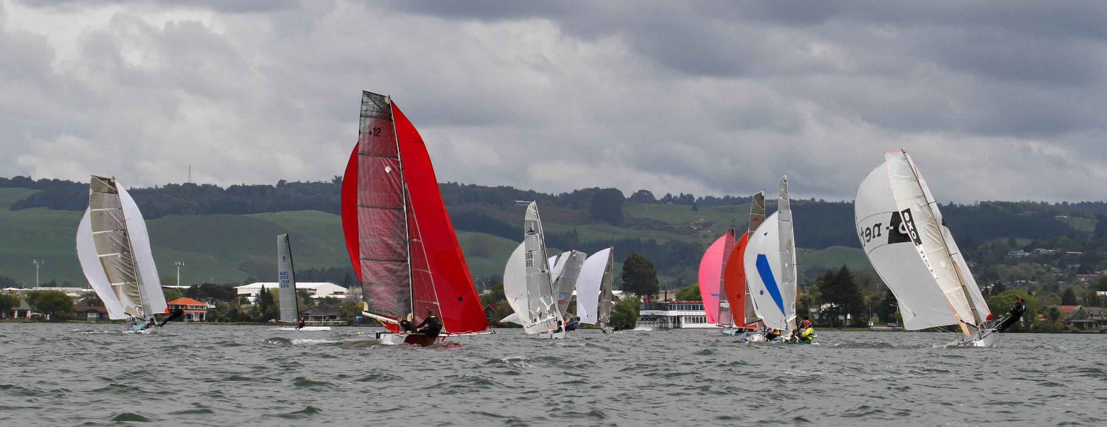
ROTORUA YACHT CLUB
2019 NORTH ISLAND SPRINTS

19th & 20th October 2019
SATURDAY 19th Briefing @ 10.30am, 1st Race Starts at Midday 5 to 7 races
Snacks available from the kitchen throughout the day
Food available in the evening (pre orders necessary) Bar open after racing
SUNDAY 20th 1st Race Starts at 10.30am. 5 Races
Snacks available from early, in the kitchen

Entry $70 (for crewed boats)
$50 for single handed
(please note additional $5 per person to cover imposed Rotorua Water Sports Trust Levy is not included in the prize pool)

CASH ONLY No eftpos at the Club

5 Boats to make a class

7 Boats for a separate start

This is a fast paced racing regatta and only suitable for experienced race sailors.
For more info contact rotoruayachtclub@gmail.com or Robin Parr Robin.Parr@scionresearch.com Phone 07 348 9490

